Generative AI Workshop

Unlocking the Potential of Generative AI:

This workshop offers an insightful exploration into the application of artificial intelligence within professional environments. Delve into the capabilities of generative AI across diverse domains, including content generation, design automation, data analytics, and customer interaction. Participants will gain a comprehensive understanding of how to leverage generative AI to drive efficiency, creativity, and strategic advantage in the modern workplace.

Topic presentation

Overview of AI

What is Generative AI vs AI?

Type of Generative AI based on data

Tasks can be performed by generative AI

What is prompt Engineering

Workshop will be as follow:

Workshop 1: Customise prompt to complete work task- Sentiment analysis, information extraction

Workshop 2: Exploring the multimodal Gemini to chat with image to extract information

Demo: LLM agent chat with your data

Workshop

Workshop 1

**Customise prompt to complete work task- Sentiment analysis, information extraction and Question/Answer**

1. Login in the Google account

Goto https://gemini.google.com/

2. Start Chatting

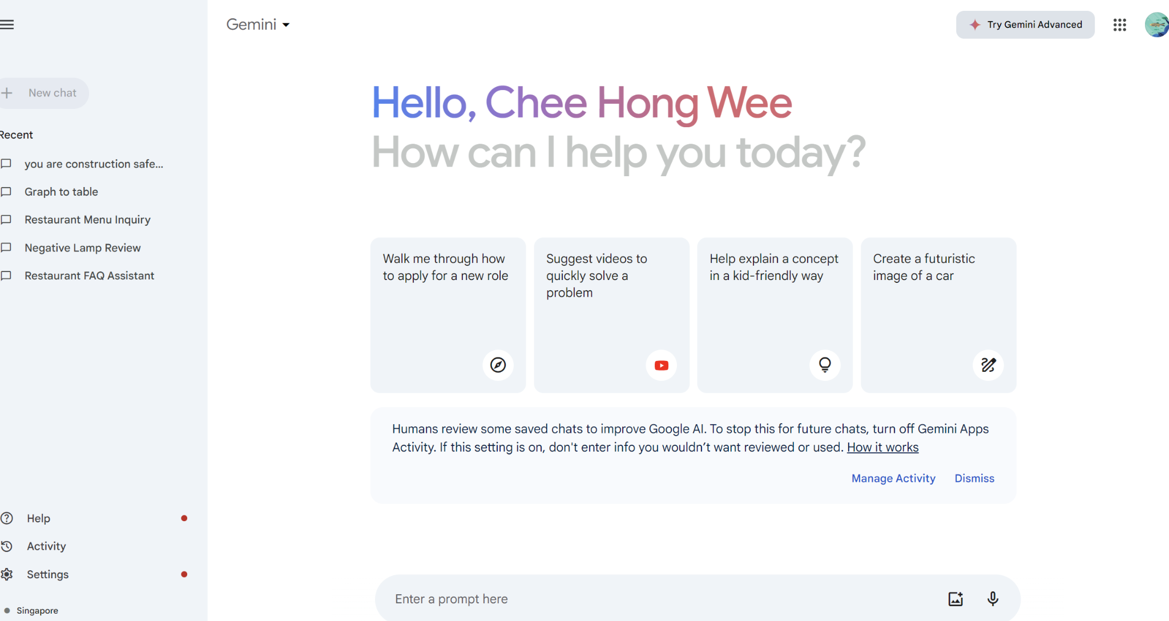

3. use the gemini LLM as a sentiment analysis AI model to predict customer review

Sentimental Analysis

System prompt

Identify the following items from the review text:

- Sentiment (positive or negative)

- Is the reviewer expressing anger? (true or false)

- Item purchased by reviewer

- Company that made the item

The review is delimited with triple backticks. \

Format your response as a JSON object with \

"Sentiment", "Anger", "Item" and "Brand" as the keys.

If the information isn't present, use "unknown" \

as the value.

Make your response as short as possible.

Format the Anger value as a boolean.

User prompt

Review text: '''{lamp_review}'''

**Note : Replace the {lamp review}” by example 1 first then example 2

example 1

The lamp design is terrible. The color used are dull.\

The light brightness is too dim and not clear. I am upset \

to that it is total different from what I saw in the shop. \

I call the customer service but there is no staff answer the call.\

Lumina seems to me to be a terrible company that don't cares \

about their customers and products!

answer:

{

"Sentiment": "negative",

"Anger": true,

"Item": "lamp",

"Brand": "Lumina"

}

example 2

Needed a nice lamp for my bedroom, and this one had \

additional storage and not too high of a price point. \

Got it fast. The string to our lamp broke during the \

transit and the company happily sent over a new one. \

Came within a few days as well. It was easy to put \

together. I had a missing part, so I contacted their \

support and they very quickly got me the missing piece! \

Lumina seems to me to be a great company that cares \

about their customers and products!!

answer:

{

"Sentiment": "positive",

"Anger": false,

"Item": "lamp",

"Brand": "Lumina"

}

4. Use the gemini LLM as AI Name entity recognition

Name Entity Recognition

System prompt

For each text, mark NER tags.

Tag categories: art, building, event, location, organization, other, person, product

Text: I went to Central Park when I was at PyData in New York

Marked Text: I went to [Central](location) [Park](location) when I was at [PyData](event) in [New](location) [York](location)

User prompt

Text: {prompt}

**Note : Replace the {lprompt} by example 1, example 2 and example 3

example 1

The mona lisa portrait is displayed in the Metropolitan Museum of Art – New York City

example 2

The mona lisa portrait is displayed in the Metropolitan Museum of Art – New York City with the free entry sponsor by Google Inc.

example 3

in the bustling streets of New York City, John purchased a new laptop at the Apple Store located inside the iconic Empire State Building.

5. Create a Question and Answer Bot

You are question and answer bot.

Following are the possible Q&A regarding the restaurant.

Understand the user input question match to the answer provide in the following FQA. If you cannot find the answer to the question respond to user you do not have the answer.

Here's a FAQ for the restaurant:

Fiktives Restaurant: Gourmet's Delight

Q1: What is the name of the restaurant?

A1: The restaurant is named "Gourmet's Delight".

Q2: Where is Gourmet's Delight located?

A2: It is located in the heart of downtown, on Maple Street.

Q3: What type of cuisine does Gourmet's Delight offer?

A3: Gourmet's Delight specializes in a fusion of Mediterranean and Asian cuisine.

Q4: Is the restaurant vegetarian-friendly?

A4: Yes, there is a wide range of vegetarian and vegan options available.

Q5: Does Gourmet's Delight accept reservations?

A5: Yes, guests are encouraged to make reservations, especially on weekends.

Q6: Are there any special dishes that are recommended at Gourmet's Delight?

A6: The signature dish is the 'Medit-Asian Fusion Platter' which includes a variety of specialties.

Q7: What are the operating hours of the restaurant?

A7: The restaurant is open from 11:00 AM to 10:00 PM, Monday through Sunday.

Q8: Does Gourmet's Delight offer any special promotions?

A8: Yes, there are happy hour discounts from 4:00 PM to 6:00 PM on weekdays.

Q9: Can Gourmet's Delight accommodate large parties or events?

A9: Yes, the restaurant has a private dining area that can be reserved for events and parties.

Workshop 2

**Exploring the multimodal Gemini to chat with image to extract information**

1. Upload menu.jpg image

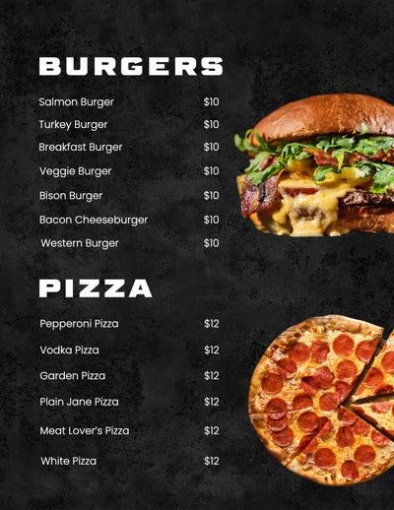

enter prompt:

You are a customer service bot. use the information from the image to answer the customer questions.

enter prompt:

how much it cost to buy 2 white pizza and 1 salmon burger?

enter prompt:

list the food that has no meat?

2. Upload ingredients.jpg image

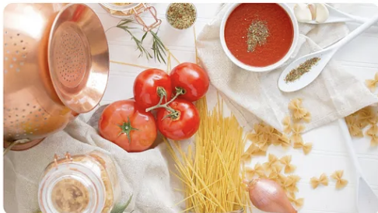

enter prompt:

What recipe can you make with these ingredients?

enter prompt:

can break into steps for me

3. Upload ocr.jpg image

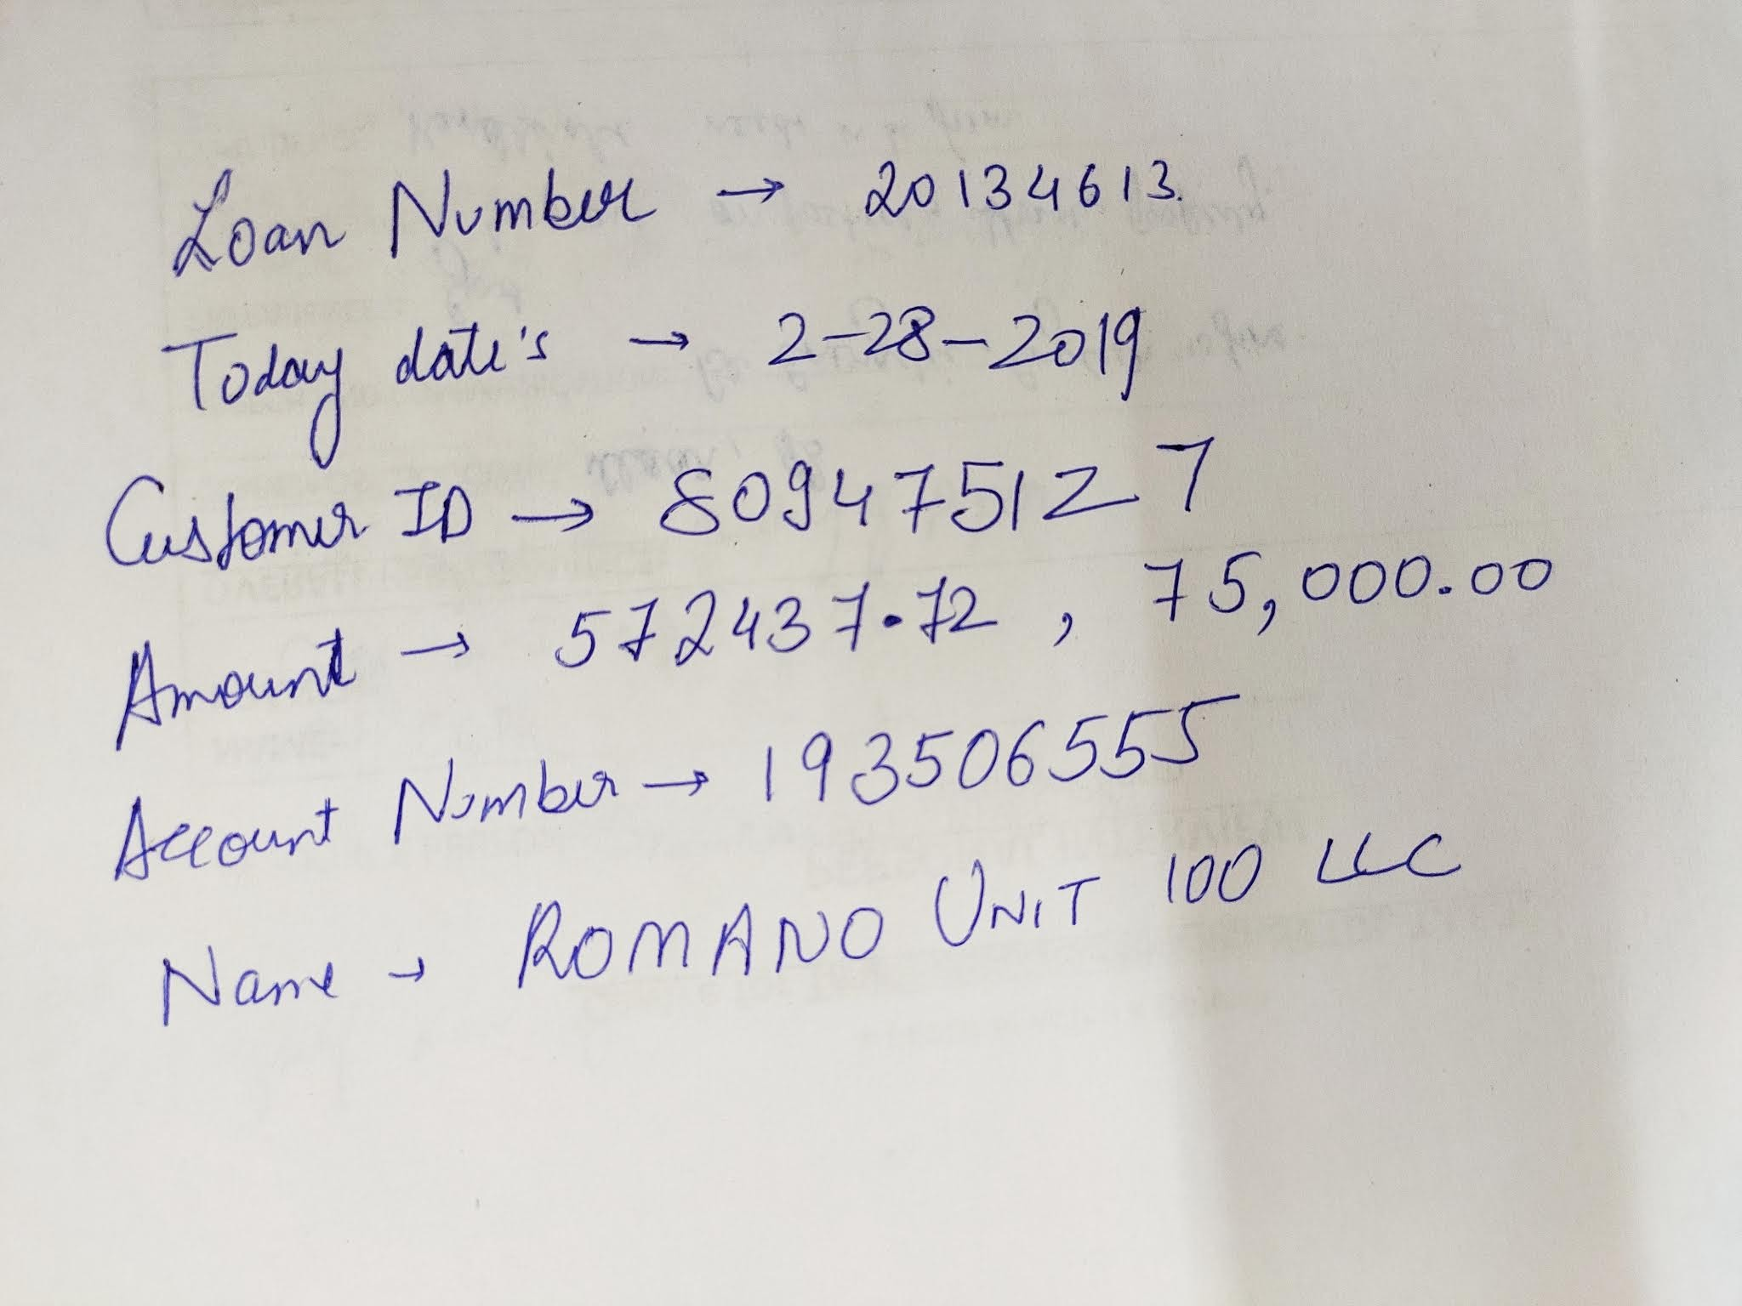

enter prompt:

*Read the image information and extract all the text*

4. Upload license.jpg image

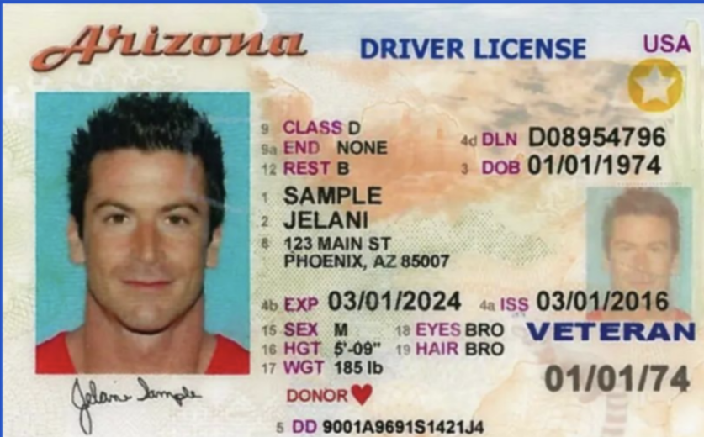

enter prompt:

*read the text in this image and return the information in JSON format(note xxx is placehoder, if the information is not available in the image, put "N/A" instead). {"calss":xxx, "DLN":xxx, "DOB":xxx, "Name":xxx, "EXP":xxx, "ISS":xxx, "SEX":xxx, "HGT":xxx, "WGT":xxx, "EYES":xxx, "HAIR":xxx, "DONOR"xxx}*